ALZHEIMER’S ADJUSTABLE CURRICULUM PROTOTYPE

Developed in 2014 as a curriculum for high school students by Grace O’Keeffe (Hudson High School of Learning Technologies Honors Senior Seminar Creator & Teacher) & Amber Roniger (Next-Gen Advocate & Filmmaker)

Please feel free to offer us feedback at: gokeeffe@hudsonhs.com & bxfconsulting@gmail.com

Overview:
There is currently very little education and/or curriculum available about Alzheimer's, caretaking for Alzheimer's patients, or impact on family members and friends. In the United States, more than 5 million people have Alzheimer’s, and there are 3x as many caregivers. In 2013, 15.5 million caregivers provided an estimated 17.7 billion hours of unpaid care. In New York State alone, 23% of caretakers are under the age of 18.

Alzheimer’s is in our high schools – in the form of kids caring for their parents with early-onset AD, and witnessing their grandparents live with and die from it. We cannot afford to delay education about Alzheimer’s any longer. We hope this serves as a basis for Alzheimer’s curriculums for schools and organizations throughout the country, and offers support to students and educators.

For Educators:
We have attempted to offer educators as much choice and flexibility as possible. In each session, we offer videos, articles, discussions, written reflection questions, headspace for breaks, and a “Dig Deeper” section for extension learning. Please approach the curriculum in the best way for you. We’ve also included Resources, including agencies to contact and categorized resources.

Topics:
We believe that topics around Alzheimer's address many of humanity’s biggest questions and concerns about life. Some themes addressed include: identity, love, policy, forgiveness, science (citizen scientists), care, responsibility, elderly, fidelity, work vs. passion, caregivers and anger/guilt.

(7/21/2015) Note: As Alzheimer’s research is constantly developing, this curriculum will be updated at least every six months.

Session #1 - What Is Alzheimer’s & Its Impact?

Intro Activity (5 min + 3 min discussion):
- Write the word Alzheimer’s on the board
- Ask students to quietly and independently free word associate, free write, or free draw their knowledge and experience with Alzheimer’s (these should be kept private)
- An open discussion for “wisdom in the room” should follow this short activity

Introduction To Alzheimer’s Videos (20 min):
- “Experience 12 Minutes in Alzheimer’s Dementia” - ABC
  - What exactly is a loved one with dementia going through? (12-minute virtual Alzheimer's tour reveals the reality)
  - Whoa/ah-ha moment (2 min) – reflection: What strikes you?

- “What is Alzheimer's Disease?” - David Shenk  - Animated video about the science of brain changes as the disease progresses (may be technical for some students, but please highlight important pieces to get a better understanding) | 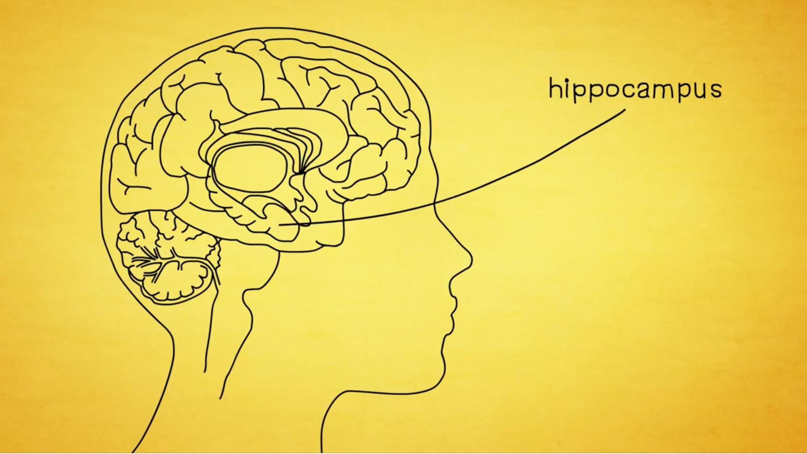

- “What is Alzheimer's Disease? - Ivan Seah Yu Jun” - TedEd  - Alzheimer's disease is the most common cause of dementia, affecting over 40 million people worldwide. And though it was discovered over a century ago, scientists are still grappling for a cure. Ivan Seah Yu Jun describes how Alzheimer's affects the brain. | 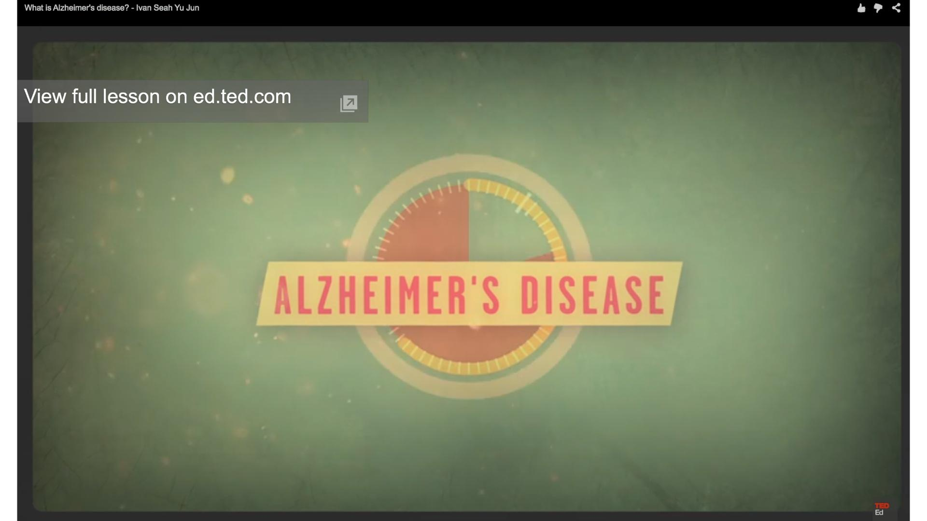

- “Understanding Alzheimer’s” - with Rudy Tanzi, PhD  - Dr. Rudy Tanzi of Harvard Medical School/Massachusetts General Hospital is a leading researcher in the Alzheimer’s field. He has co-discovered the three familial early-onset Alzheimer’s genes. In 2014, his lab developed “Alzheimer’s in a Dish,” a 3D model of a human brain with Alzheimer’s. | 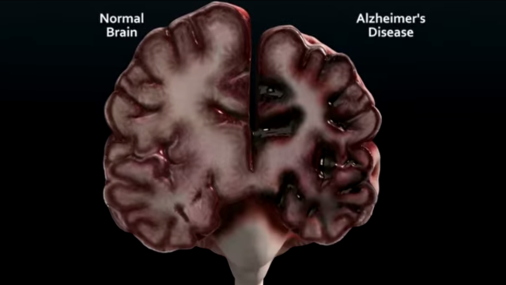

Reading (15 min):
- “What you Need to Know About Alzheimer’s” - Women’s Health
- “Slow Dancing With a Stranger” - Meryl Comer Book  - Read/download the Introduction: merylcomer.com/book  - From Emmy award–winning broadcast journalist and leading Alzheimer’s advocate, Meryl Comer, comes a profoundly intimate and unflinching account of her husband’s battle with Alzheimer’s disease, one of today’s most pressing—and least-understood—health epidemics. | 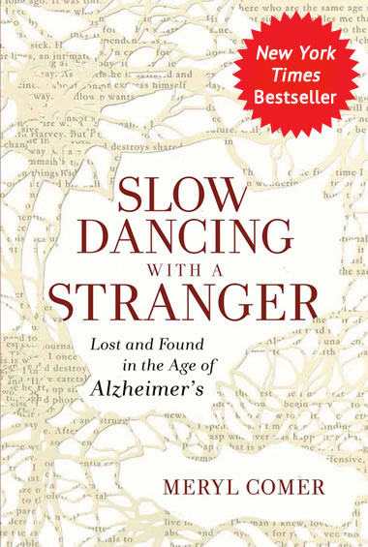

Written Reflection/Online Discussions (10-15 min):
- Researchers around the world have been searching for a cure for Alzheimer’s disease for a very long time - are governments, societies and scientists doing enough?
- What are some of the issues that have prevented us from finding a cure?

Headspace (10 min):
- Dig Deeper
  - @GBFAI
  - merylcomer.com

- Movies
໐ “Still Alice” - 2015 Feature Film  Alice Howland, happily married with three grown children, is a renowned linguistics professor who starts to forget words. When she receives a devastating diagnosis, Alice and her family find their bonds tested. | 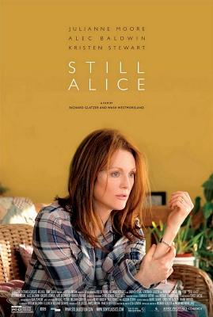
- Documentaries
໐ “I’ll Be Me” - Glen Campbell Story  In 2011, music legend Glen Campbell set out on an unprecedented tour across America. They thought it would last 5 weeks instead it went for 151 spectacular sold out shows over a triumphant year and a half across America. | 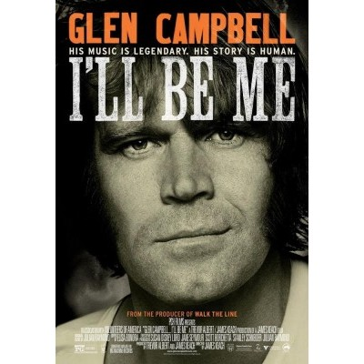

໐ “The Alzheimer’s Project” - HBO Series  One of the most devastating forms of memory loss is Alzheimer's disease, an irreversible and progressive brain disorder that slowly destroys memory and thinking skills. Today, Alzheimer's is the second most-feared illness in America, following cancer, and may affect as many as five million Americans. | 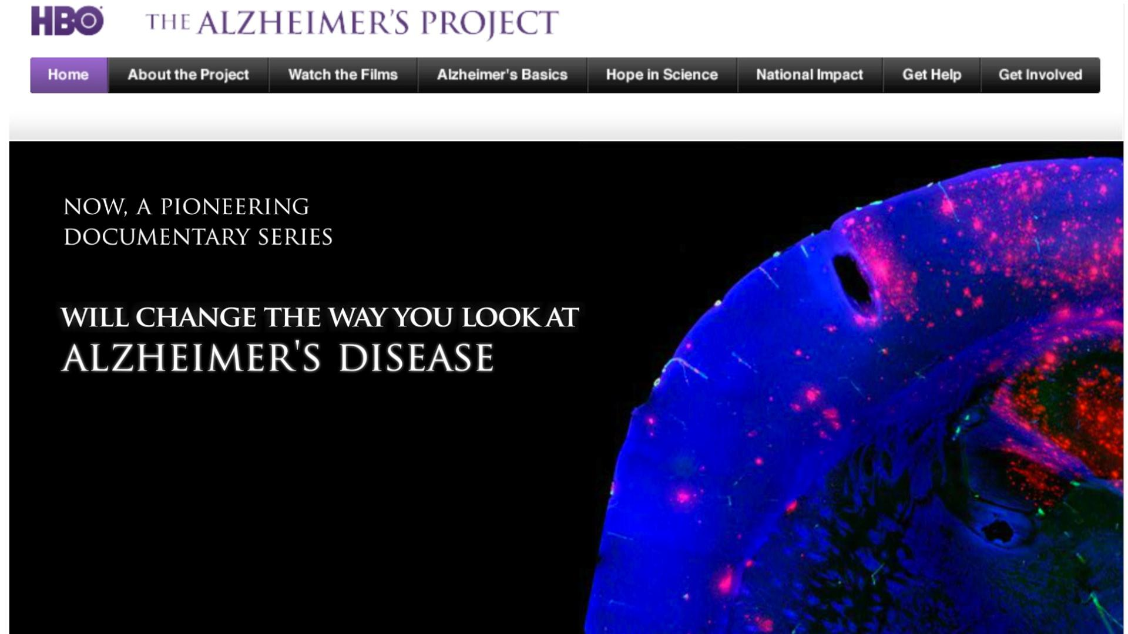

- Living With Alzheimer’s Film Project  Tell us your story. A new annual competition for short films about dementia. Grand prize: $5,000. | 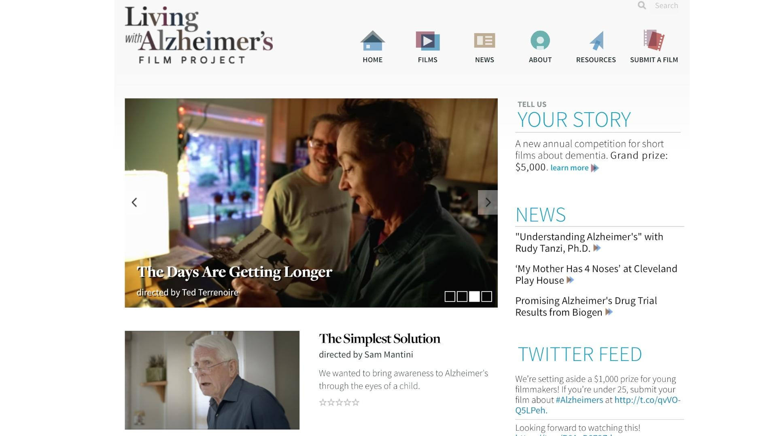

Session #2 – Identity

Intro Activity (10 min):
- Make a list of descriptions of yourself
- Write down your top five memories
- Feel free to have students share

Discussion (5 min):
- What makes up a person's identity?
- What would happen if those five memories were taken away?

Identity Video (10 min):
- “What is Consciousness?”  Our World is Amazing. Vsauce was created by Michael Stevens in the summer of 2010. | 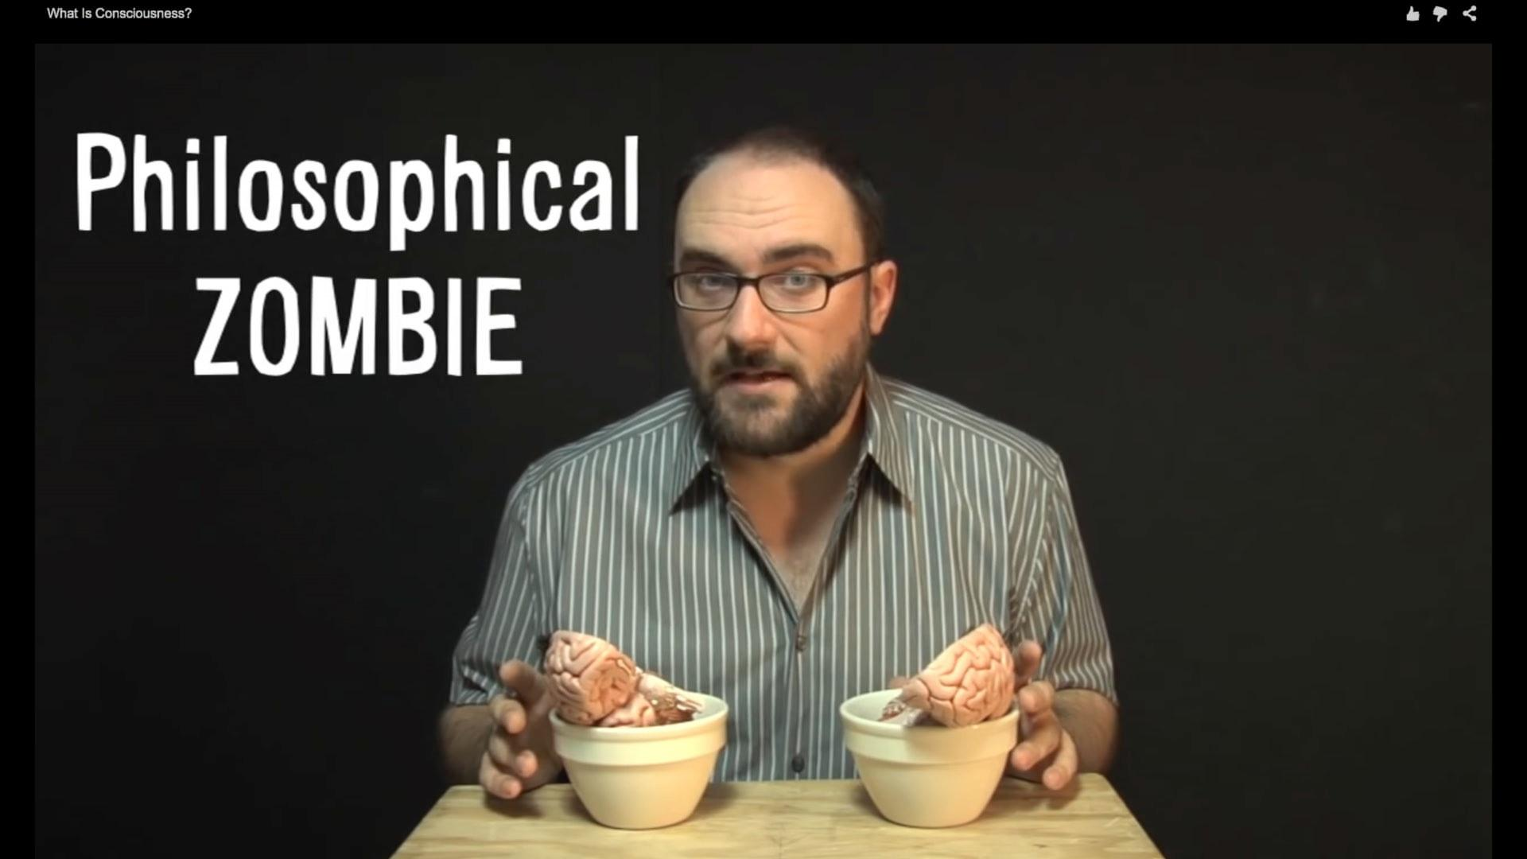
Alzheimer’s and Identity Article (15 min):
- “Alzheimer's Challenges Notions of Memory and Identity” - NPR article
  - Are we our:
    - Memories?
    - Morality?
    - Personality?
    - Basic cognition?

Reflection (10 min):
- What do you think most impacts identity?
- At what point, does a person lose their identity?
- Who decides?

Headspace (10 min):
- Dig Deeper: Videos/documentaries/articles for questions and understanding around identity
  - “Where Does Identity Come From?” - Scientific American
  - “How The Brain Builds Identity” - HuffPost Tech

Session #3 – Caregiving

Intro activity (10 min):
- What does care mean?
- What emotions might a caregiver feel?
- Who cares for our family members in need?
- Who is responsible?
  - Teens?
  - Families?
  - Facilities?

ABC Nightline Video (10 min):
- “This is not going to be your typical story about Alzheimer’s disease. You’re going to visit a photo shoot for GQ Magazine with music stars, Sheryl Crow and will.i.am. You’ll get to come into my office and watch me spit in a tube.” -Terry Moran
- “Terry Moran’s Moment of Truth, Part 1” | 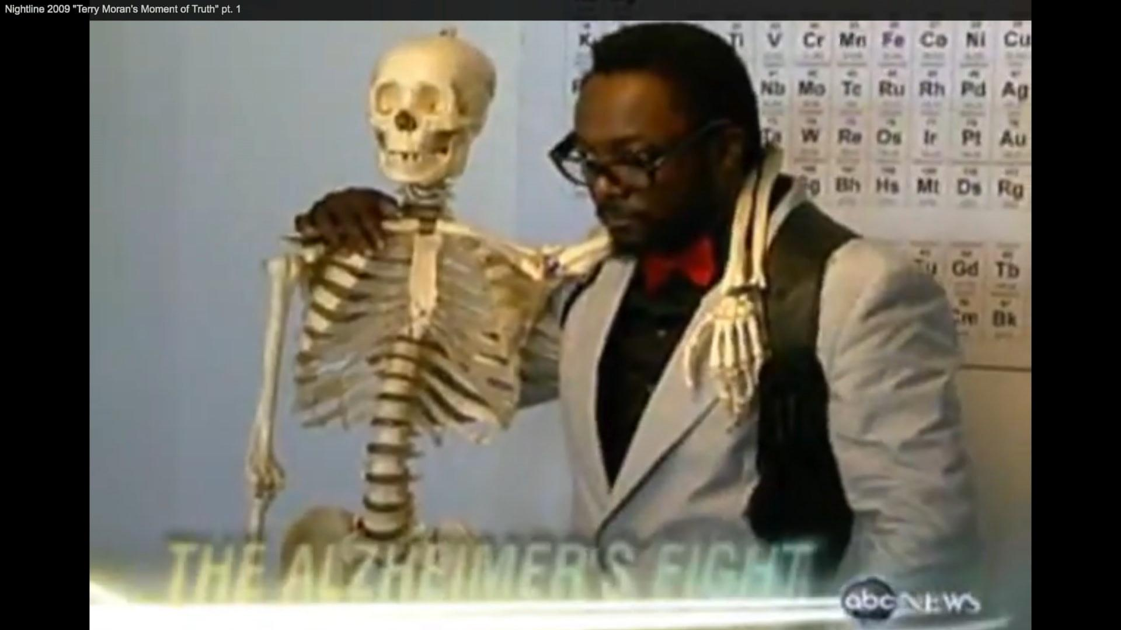

- “Terry Moran’s Moment of Truth, Part 2” | 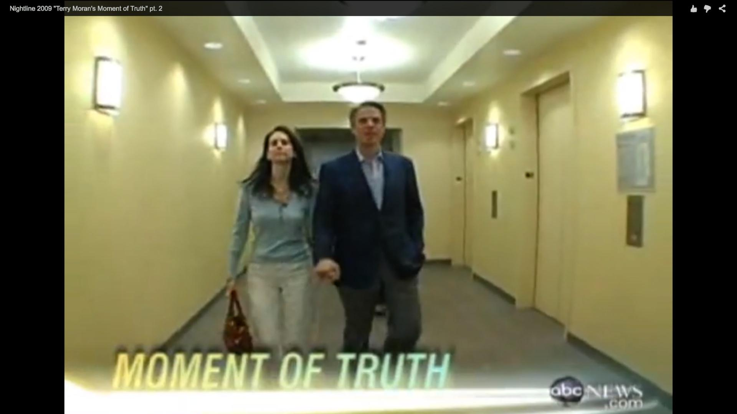
Jigsaw Protocol (20 min):
- Divide students into three groups to read, watch, dissect, ask questions, and be curious together for 10 minutes (it is up to you how to divide your group)
- Tell students that the second part of the protocol will require them to briefly describe their “piece” of the puzzle and reflect on the discussion question
  - Group 1: “In Six Words, What’s a Caregiving Fear?” - Caregiving Forum
  - Group 2: “Mindfulness Training Helps Alzheimer's Patients and Caregivers” - CBS
໐ Group 3: “Caring for the Caregiver” Video  Anchor Mike Walter is joined by Lynda Shrager, occupational therapist and featured blogger at "Everyday Health: The Organized Caregiver," to discuss the challenges caregivers face in balancing their own needs with those of their loved ones. | 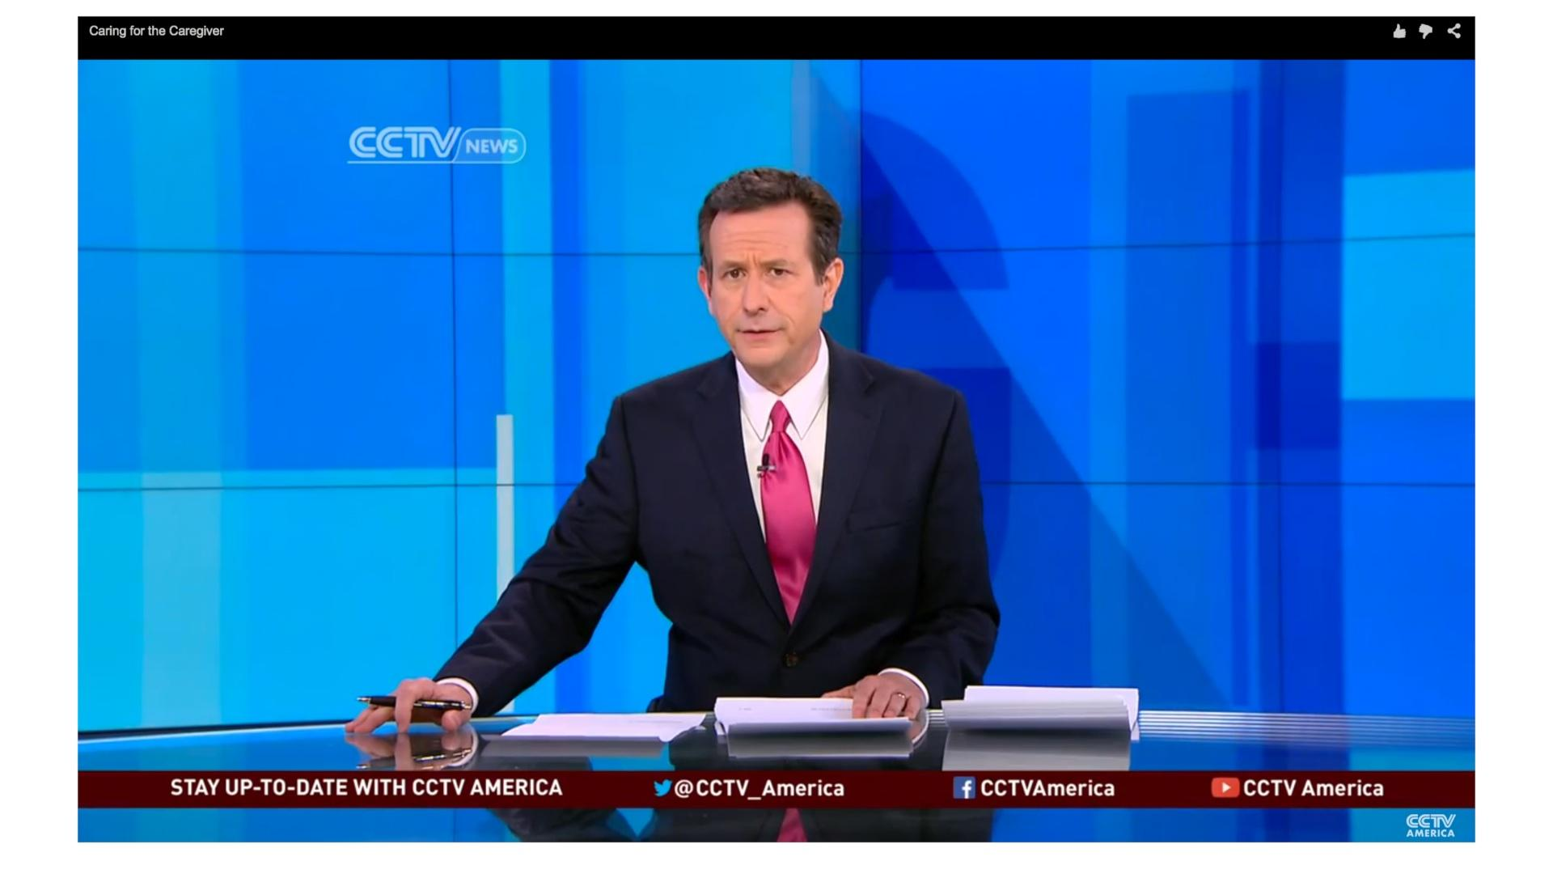

Discussion (10 min):
- What are feelings associated with caregiving?
- Fears?
- Emotions?
- Briefly describe your “piece”

Reflection (10 min):
- How are caregivers supported in our culture?
- How might we better support them?

Headspace (5-10 min):
- Dig Deeper
- Who Takes Care of the Caregiver? - New York Times
- Five New Movies Explain Why Caregiving Is Real Work - Washington Post
- Movies for Caregivers

#4 - The Brain

Intro Activity (20 min):
- What is the brain?
- What happens in the brain?

Brain Videos - Explaining the Brain:
- “Everything’s Controlled by the Brain: The Body Rocks”  Doc Dauer Presents The Body Rocks! Songs about the Human Body. Learn about how the Brain works with this video. | 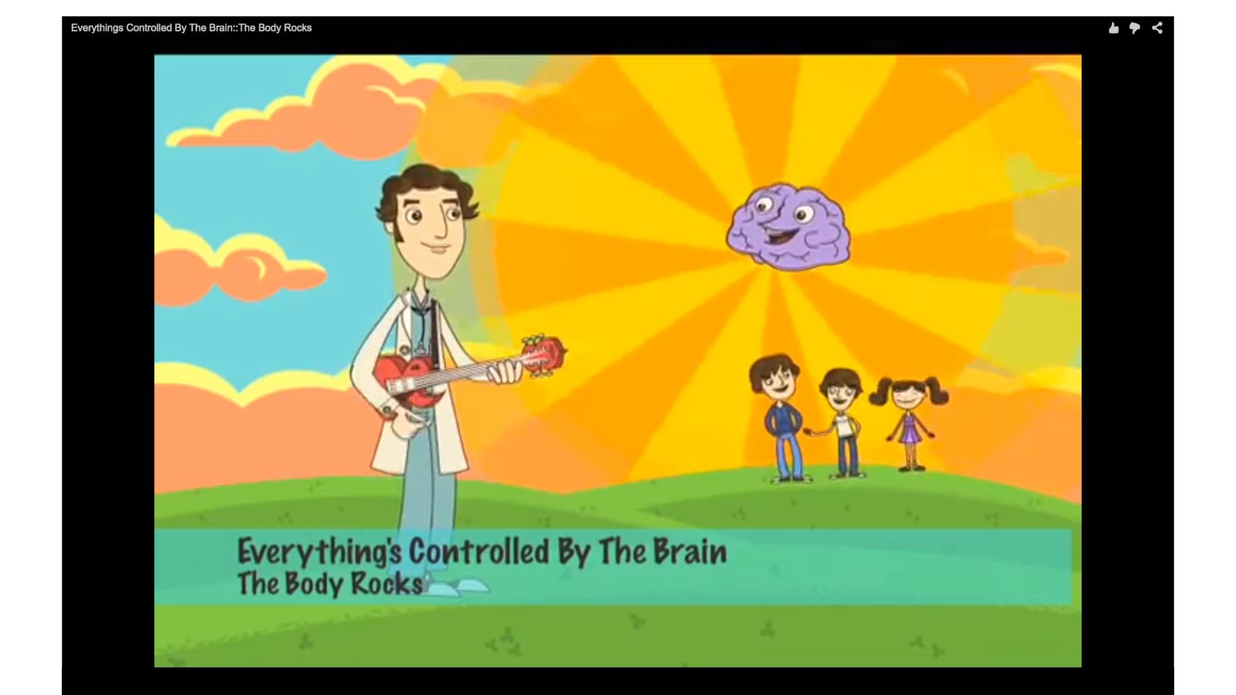

- “Brain Tricks - This Is How Your Brain Works”  Ever wonder how your brain processes information? These brain tricks and illusions help to demonstrate the two main systems of Fast and Slow Thinking in your brain. Written and created by Mitchell Moffit. | 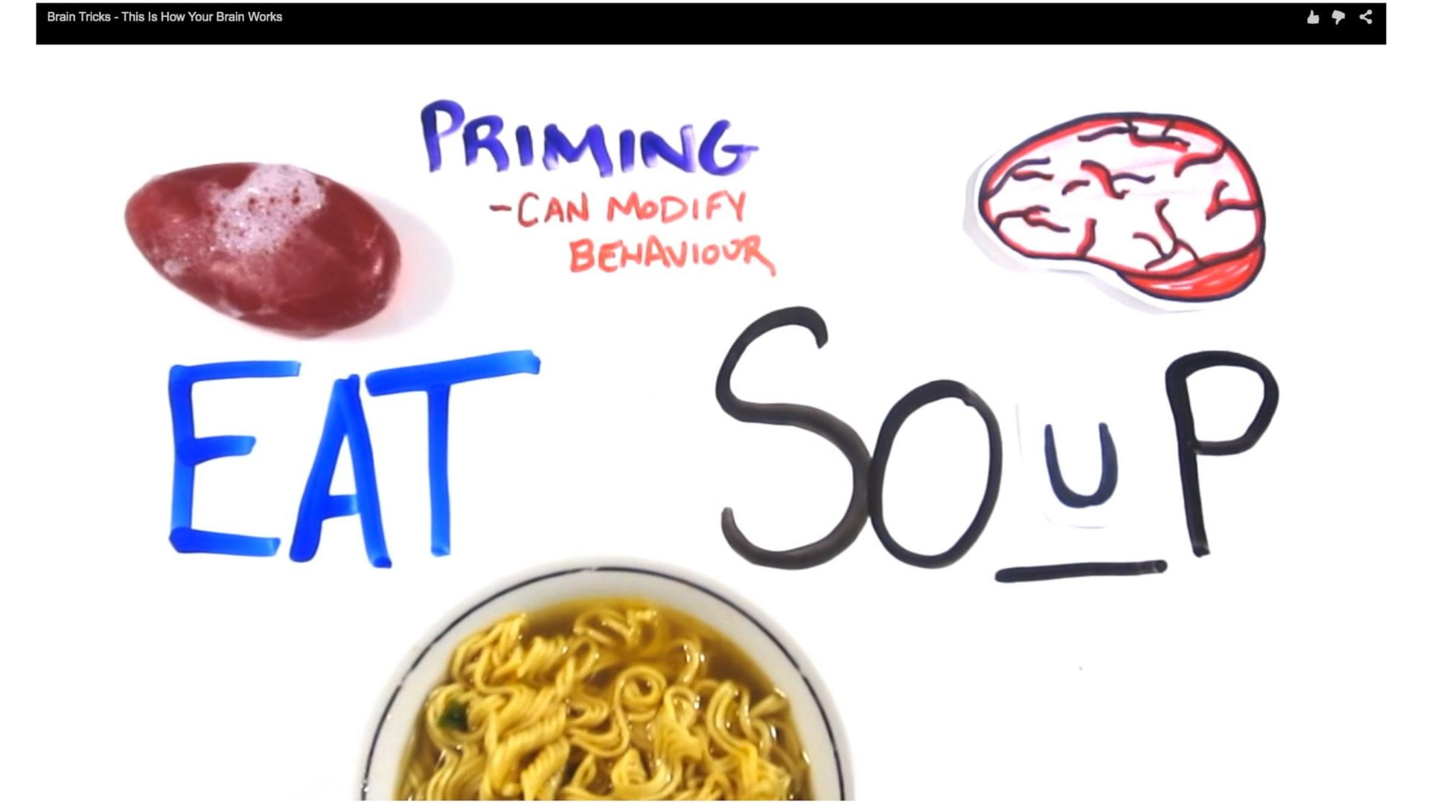

- “How The Brain Works”  The Sentis Brain Animation Series takes you on a tour of the brain through a series of short and sharp animations. The first in the series introduces you to the most fascinating part of your body - The Brain. | 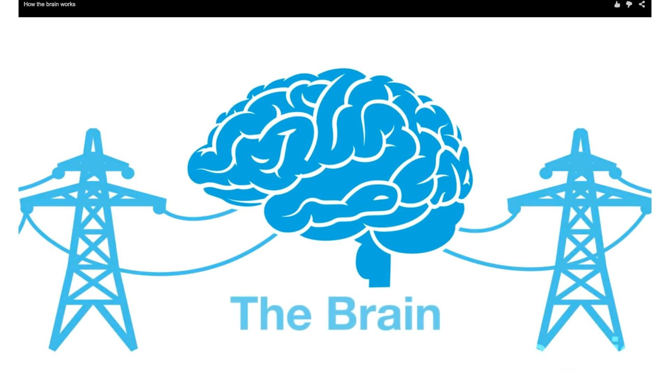

- Right and Left Brain Workout Brain Exercise Video  Are you 'left brain' or 'right brain?' Do you know the difference? You've probably heard that people are supposed to be one or the other and, in a way, there is some evidence that each of the two hemispheres of the brain tend to be activated for different kinds of tasks. | 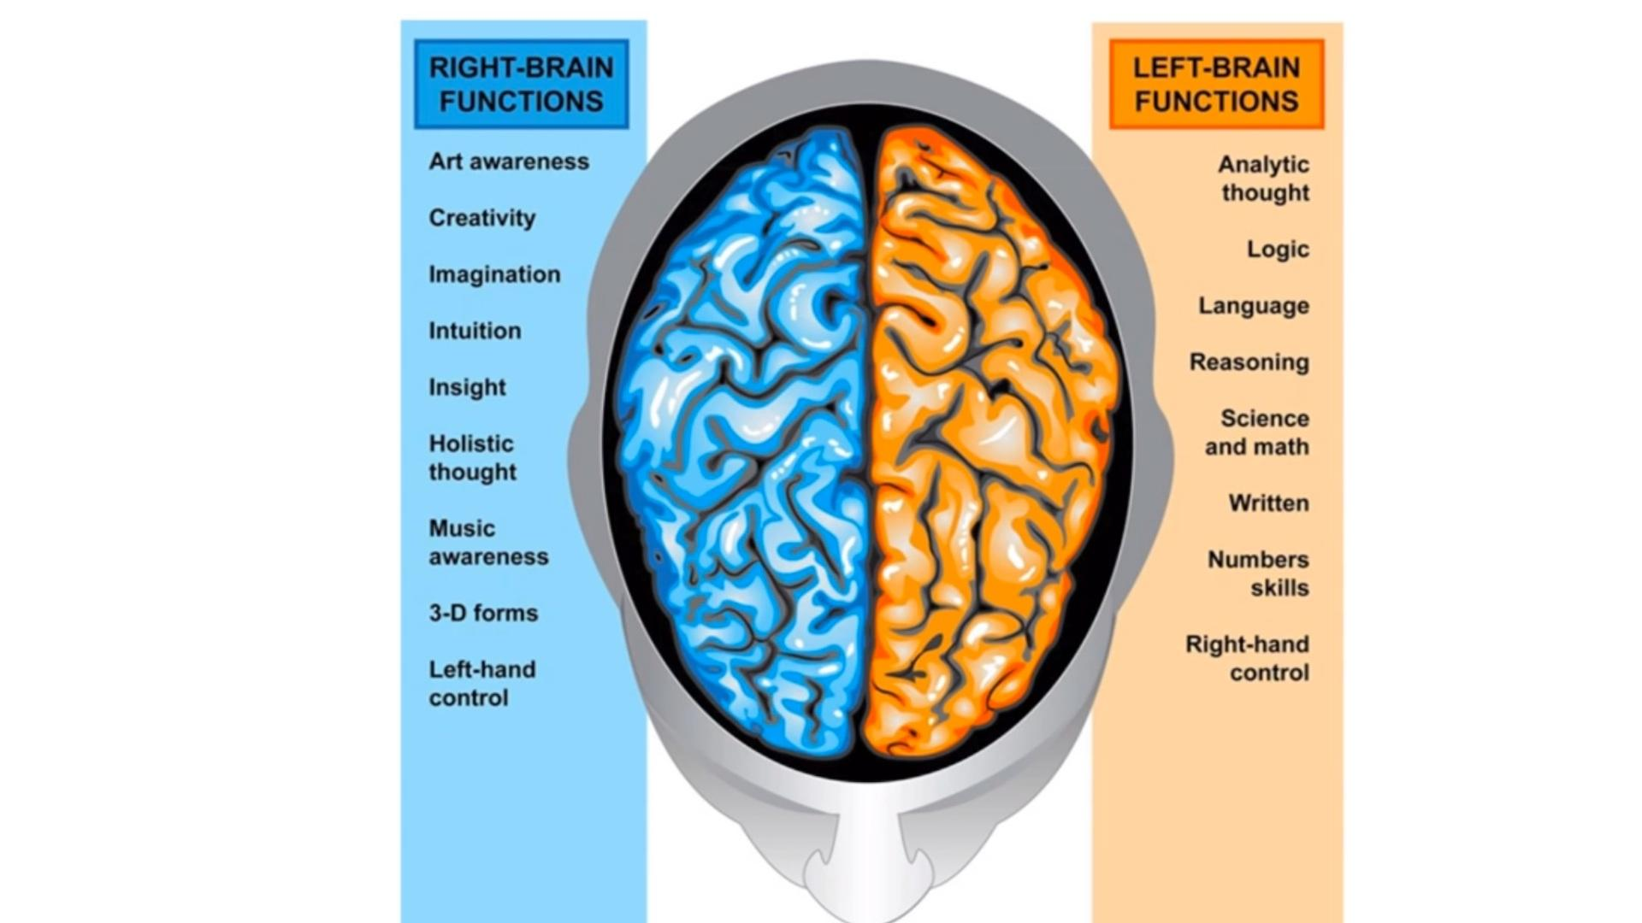

Article:
- “Unlocking the Brain: Are We Entering a Golden Age of Neuroscience?” - Common Health

Games for the Brain:
- Lumosity
- Scrabble
- Online Games
- Strategy Games

Reflection (10 min): Why is brain health not just for the elderly? What can we do now to ensure our brain health? List some tangible actions.

Headspace (10 min):
- Check-in with students
- Play some online brain games

Dig Deeper (10 min):
- “Playing for Prevention: Alzheimer’s and Keeping the Mind Sharp” - HuffPost Healthy Living
- “High-Intensity interval Training and Brain Health” - Brain Blogger
- “Brain Health” - NutritionFacts.org
- “How Does the Brain Work?” - Nova Science Now Documentary with Neil deGrasse Tyson  This documentary delves into some pretty heady stuff, examining magic and the brain, artificial intelligence, magnetic mind control, and the work of neuroscientist and synesthesia researcher David Eagleman. Can we really believe our own eyes? | 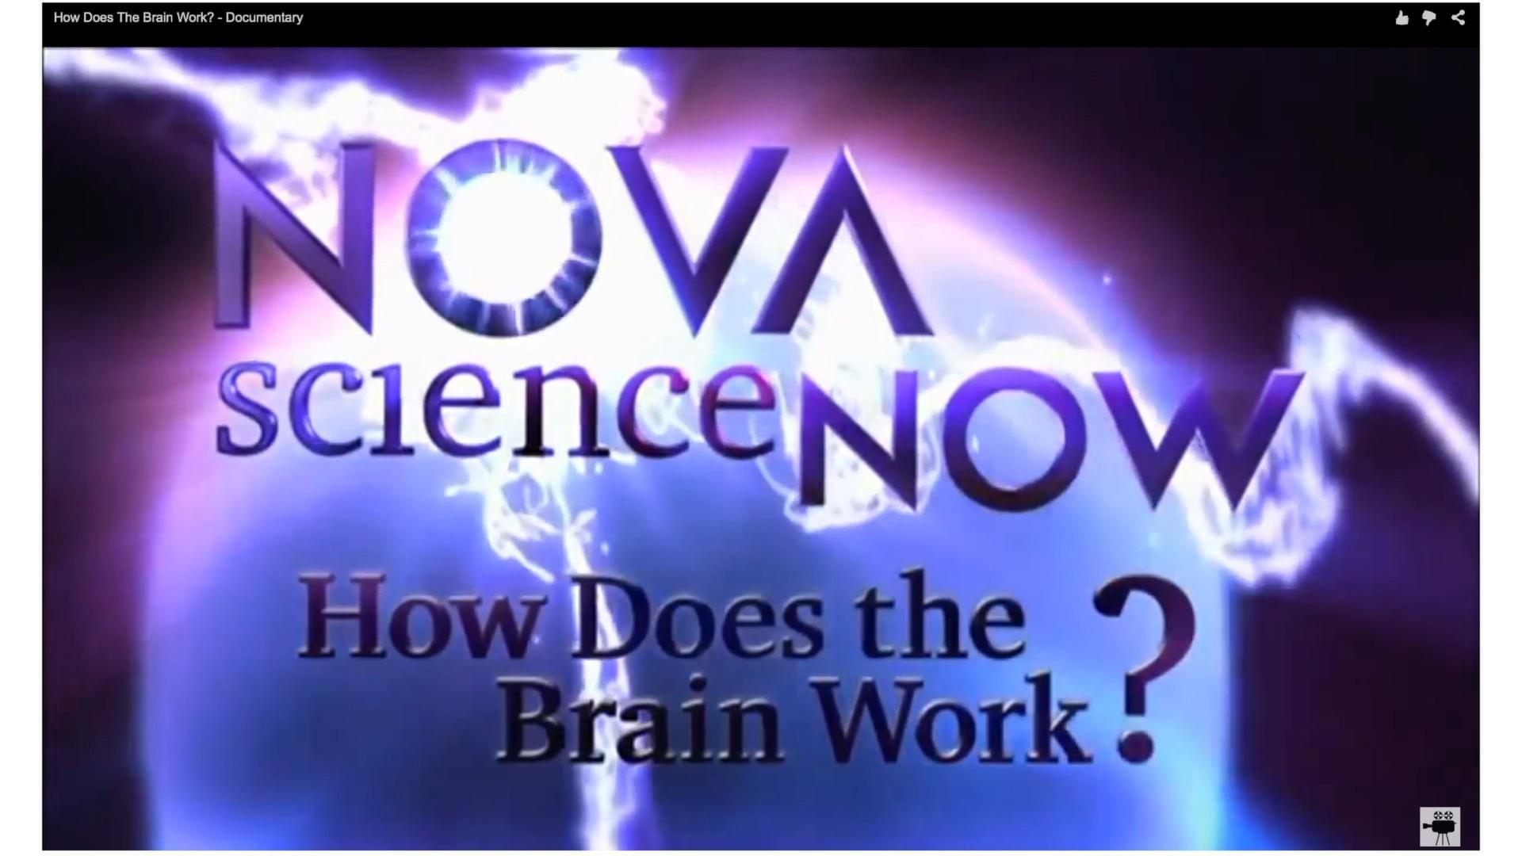

Session #5 - What can I do? (What do you live for?)

Intro activity (5 min):
- What do you think you can do for Alzheimer’s?
- There are numerous ways to support work around Alzheimer’s patients, caregivers, and families. Today we will look at four different Alzheimer’s advocates and YOU will be given time to brainstorm what YOU can do for Alzheimer’s. Remember that even talking to someone about Alzheimer’s is important advocacy work.
- Meryl Comer/Advocate and Caregiver: “Maryland Woman Pens the Story of the Ordeal of her Husband’s Alzheimer’s” - The Washington Post
- Max Wallack (science/advocacy/youth): Max Wallack - Youth Advocate & Alzheimer’s Researcher
- Scientists: “Rock Stars of Science” Video
- Jarius Pierre-Toussaint/ Former Student, Advocate: Alzheimer’s SnapChat Proposal

Brainstorm/Work Time (20 min):
- Student work time

Dig Deeper:
- Teacher “feeder” lines, suggested articles if kids get stuck
- Links to Student Projects - Luz’s Project, Angel’s Project
- “Living With Alzheimer’s” Film Project

Session #6 - Work & Share-Out

Intro Activity (5 min):
- What do you most care about around Alzheimer’s?
- Based on responses and the last session, form student groups around what students care about. Some possible areas to further include:
  - Policy (economic, health, education)
  - Advocacy/social media
  - Scientific proposal
  - Health: prevention, slow-down, cure, treatment, support (database)

Brainstorm/Finalizing Ideas (30 min):
- Some guiding questions:
  - What are you going to do about it?
  - What information do you need?
  - Why do teens care?
  - Design an action plan
  - Share ideas

Feedback Carousel (20 min):
- Protocol from National School Reform Faculty:
The purpose of the feedback carousel is to get a variety of different kinds of feedback from a large number of people in a relatively short period of time especially for getting feedback on a plan for any future work.

To set up this activity, have each person or team display the significant elements of their plan on a piece of chart paper. Encourage the use of color and creativity.

Next to each piece of chart paper, put up another chart paper that is divided into 4 parts. The top left quadrant is for clarifying questions, the top right quadrant is for probing questions, the third quadrant is for recommendations and the fourth quadrant is for resources that would be useful to the planning team. Distribute small post-its to every participant and ask them to rotate through as many plans as time permits and write feedback on a post-it and place the feed back in the appropriate quadrant.

Allow a few minutes to debrief the process

Next steps (10 min):
- What do we want to do?
- What do we need to do to get there?
- Long term project? Later projects?
What can we do right now?

Resources

Alzheimer’s Disease:
- “What Is Alzheimer’s Disease?” Video - David Shenk
- “The Alzheimer’s Project”- HBO
- “Memory Loss Protein Identified” - Newsweek
- “‘New Clarity’ Against Alzheimer’s” - Harvard Gazette
- “Brainspan-Lifespan Connection: The Alzheimer’s Challenge” - Meryl Comer Video Highlights at Larchmont Public Library – with Dr. Richard Isaacson & Max Lugavere
- “Documentary Explores How Couples Deal with Alzheimer’s” - The Washington Post
- “How Tracking Devices are Keeping Alzheimer’s Patients Safe” - CNN Money
- 21st Century BrainTrust® YouTube Channel
- “Facing Alzheimer’s Disease” – NPR Interview/Article with journalist, Greg O’Brien & Dr. Rudy Tanzi
- “Alanna Shaikh: How I'm preparing to get Alzheimer's” - TedTalks
- “Man with Alzheimer’s Disease Drew a Series of Self-Portraits Over the Years”
- “Developing New Drugs for Alzheimer's Disease - On Our Mind” Video

Identity:
- “What Is Consciousness?” Video
- “Alzheimer's Challenges Notions Of Memory And Identity” - NPR Article

Caregiving:
- Join the Caregiver Health-eBrain Study
- “In Alzheimer's Disease, Caregiving May Be Just As Trying As the Disease Itself” - Huffpost
- “Dutch Nursing Home Offers Rent-Free Housing to Students” - PBS Newshour
- “The Best Medicine: Love in the Name of Alzheimer’s” – Radio Interview with Meryl Comer
- "Slow Dancing With A Stranger” - Book Trailer Video by Meryl Comer
- “Dementia Friendly America Initiative” Video
- “War On Alzheimer’s” - PBS Video featuring Meryl Comer
- NJ Nurse Training

The Brain:
- “Missing Link Found Between Brain, Immune System; Major Disease Implications” - Science Daily
- Keep Your Brain Stronger for Longer: 201 Brain Exercises for People with Mild Cognitive Impairment

Advocacy/Social Media:
- MerylComer – leading Alzheimer’s advocate
- USAgainstAlzheimer’s Advocacy Networks
- The A4 Study - Join Clinical Trials
- Meryl Comer Wins Alzheimer’s Drug Discovery Fund 2015 “Great Ladies” Award Video
- “The Changing Role of Open Innovation in Social Impact” - 2015 Paris Assembly Panel Video
- “Seth Rogen Says Government Needs to Step Up On Alzheimer’s” - Time
- Access Our Medicine Declaration
- Max Wallack Video - Young Alzheimer’s Researcher & Advocate

Policy (economic, health, education):
- “Alzheimer’s Adjustable Curriculum Prototype” Video
- Download Listener App - Need Someone to Talk to?
- “Initiative for Dementia Friendly America” Video
- Alzheimer’s Universe - Education Hub
- “Students Unveil Apps for Alzheimer’s Treatment” - LoHud

Agencies to Contact for Help:
- Alzheimer’s Association 24/7 Helpline

